Hair Shipping Instructions
SPIT Lab Protocol

If shipping with FedEx, UPS, DHL, etc: If shipping with USPS:

Birdie Shirtcliff c/o SPIT Lab Birdie Shirtcliff c/o SPIT Lab
1451 Onyx Street Psychology Department
Dept of Psychology 1227 University of Oregon
University of Oregon Eugene OR 97403-1227
Eugene OR 97403-1227 Email: spitlab@uoregon.edu
Email: spitlab@uoregon.edu

(1451 Onyx Street is the actual street (USPS packages go to the main mail
address and very important for packages to facilities, then sorted and delivered arrive; Department and U Oregon can to departments within 2 days)
be combined on one line if space is limited)

For shipping, please remember the following:

- Place hair samples in a foil packet (see examples).
  - For longer hair, loop the sample without bending the hair sharply (see example 1& 9).
  - Clearly delineate the scalp end of the hair by banding the hair near the scalp end, noting the scalp end marker on the foil, or preferably both (see example 1 & 2).
- Fold the foil packet such that it makes an envelope over the hair (see example 3).
- Label the foil envelope with all relevant sample information (see example 4).
- Place each single hair sample in a manila envelope.
- Label the envelope with all relevant sample information (see example 5).
- Keep the sample at room temperature.
- Label samples in a clear and legible manner.
  - Please include participant gender when possible.
- Use a shipping box to mail the samples.
- Please use a tracked shipping method.

DO NOT:
- Please do not lace a label over the edge of the foil (this will have to be cut and participant information will be lost) (see example 6).
- Please do not tape, glue or otherwise use adhesives to attach the hair to the foil (see example 7 & 8).
- Please do not use biohazard bags.
- Please do not ship hair with Saliva.

Example 1. Good example of long hair

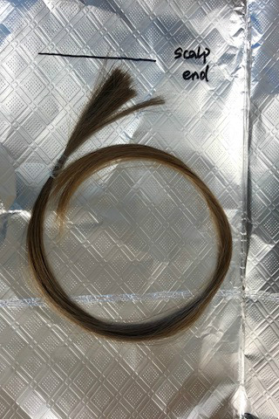

Example 2. Good example of short hair

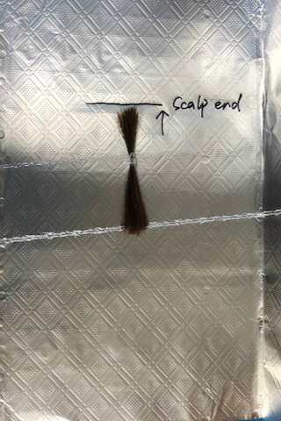

Example 3. Example of foil envelope

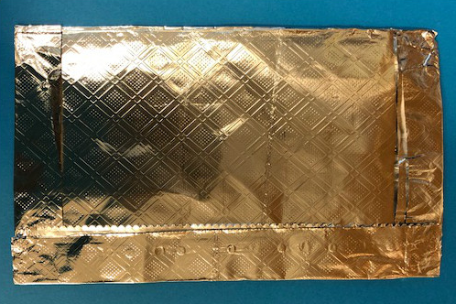

Example 4. Example of labeled foil envelope

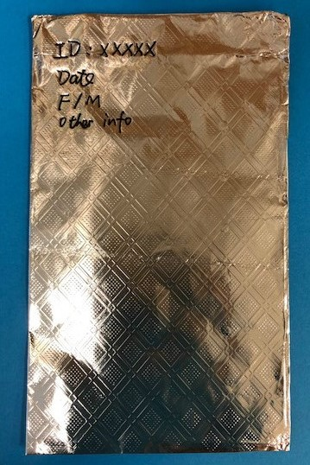

Example 5. Example of envelope

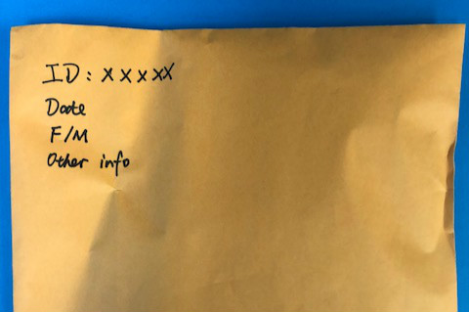

Example 6. Wrong example of sealed foil envelope

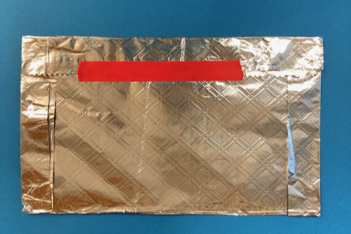
Example 7. Wrong example of taped long hair

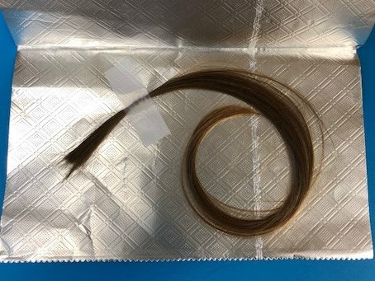

Example 8. Wrong example of taped short hair

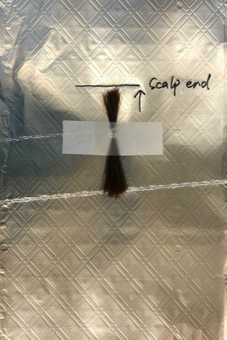

Example 9. Wrong sample of over-bent long hair

